Witching Tales

Have you ever dreamed of being a witch?

We have a VR experience for you

Team members: Hanus Ioana-Ștefana, Roman Cristian-Ioan

Features

Enumerati si detaliati informatii despre fiecare componenta principala a aplicatiei.

* As a user I will have to complete quests requested by the villagers
  + Components needed:
* The acquiring of ingredients for potions or spells
* The spell mechanics
* The potion creating
* The interactions with the villagers
* As a user I want to:
  + Have diverse potions to create
  + Have multiple spells to make
  + Have the experience of walking around the village

Scene, ecrane si Module

Enumerati scenele, ecranele si modulele aplicatiei necesare acesteia.

Scene:

* Witch house interior
* Village main street (where you meet the NPCs)
* Gathering ingredients zone

Ecrane:

* Loading Screen into witch house scene
* Loading Screen into village main street scene
* Loading Screen into gathering ingredients zone
* Loading Screen - starting the game
* Screen for the chat with NPCs
* Screen night to day transition

Module:

* Talking to NPCs
* Gathering ingredients via searching or buying
* Making potions

Componente

Enumerati componentele de care veti avea nevoie. Subliniatile pe cele pe care planuiti sa le creati de la zero (modelare etc), si scrieti sursele de unde planuiti sa le luati pe celelalte.

\*Fiti cat mai detaliati, acestea reprezentand practic un checklist pentru voi.

3D

* Witch house (Modelat)
* Interiorul casei vrajitoarei (Modelat)
* Npc’s (Modelat)
* Other houses (<https://assetstore.unity.com/packages/3d/environments/fantasy/fantasy-house-bundle-257964>)
* Cauldron (Modelat)
* Ingredients, potions
* Animals (<https://assetstore.unity.com/packages/3d/farm-animals-set-97945>)

Graphics & 2D

* Thumbnail (AI generated)
* Loading screens (Pictures of scenes, maybe edited a little)

Sounds

* <https://assetstore.unity.com/packages/audio/music/ancient-era-music-free-pack-146823>
* Sunet click
* Sunet pleosc cand pui ceva in cauldron

VFX

* Fog (<https://assetstore.unity.com/packages/vfx/shaders/height-fog-118960>)
* …

Alte asseturi

* Link 1: <https://assetstore.unity.com/packages/3d/environments/fantasy/free-cartoon-halloween-pack-mobile-vr-45896>  
  Link 2:

Journey Map

Creati un Journey Map cat mai complet care sa descrie fiecare posibil flow al aplicatiei. (Exemplu atasat)

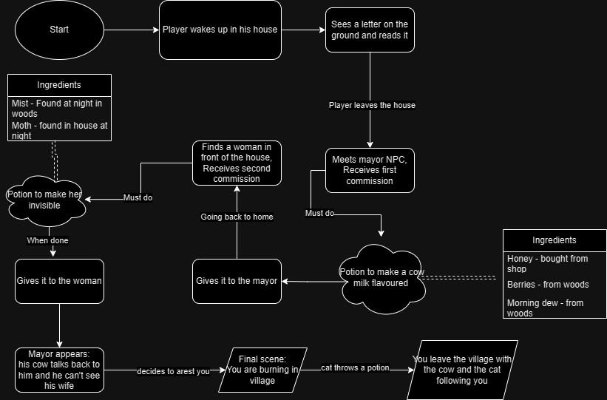

Text format:

* Starting scene:
  + someone knocking at the door
  + finding a letter:
    - Welcome from mayor
* Getting out of the house:
  + triggers NPC “hello”
    - Talk scene with NPC (about the book – hint to take a look to the receipe book)
    - first quest - a villager comes to you and tells you that there’s something wrong with his cow and that her milk has been coming out pink since 3 days ago, it tastes strange and the cow seems to be really tired. He pleads that you make a potion to fix her.
      * you buy some honey
      * you forage for some wild berries
      * you search for some morning dew from a patch of grass from the forest
      * then you make the potion:
        + you pour the dew with the honey into a cauldron filled with water
        + then you heat it up using a fire spell as before
        + then you put the berries in the water and continue mixing
      * after you’re done with it you give the potion to the man and he gives you two gold suggesting you could go to the shop
      * You go to the shop:
        + Talk with the seller: He is telling you that he could give you a cat for the witchy vibes
      * you go to sleep in the evening

(Going out to get the elements)

* Mixing the elements accordingly to the book:
  + Mush the berries in a mojar
  + Put water in cauldron
  + Add morning dew
  + Adds the honey to the potion
  + Cast a spell :
    - Appears a button to cast a spell
    - The witch mumbles something
    - Some signs/fires appear and the witch must select one class to cast the spell successfully
    - The water is starting to boil and to change GRADUALLY the water colour
  + Boil and mix the ingredients
* Opens the cauldron’s tap to pour the potion
* Goes with the potion to the NPC
* Goes back to sleep
* Next day receives a note saying that it is a wife that suspects his husband of infidelity. She wants a potion to spy his husband by making her invisible.
* Mechanic:
  + Ingredients:
    - Mist: found on streets at sunset *(found in the forest by some pond)*
    - A moth found in the house at night
  + Steps:
    - Point the wand to the mist bottle:
      * the bottle itself opens and the mist is getting out
    - Cast a spell in a similar way (this time wind images appear):
      * The mist is now in sphere shape
    - Point the want to the moth bottle:
      * the bottle itself opens but the moth stays in there
    - Cast a spell in a similar way (this time wind images appear):
      * The moth goes into the mist sphere
    - Pull the sphere with the moth in with the wand in the cauldron
    - Add moss water and water
    - Boil and mix the ingredients
* The wife arrives (after 2 days – screen required) telling you that you could have been faster.
* the following day, mayor comes with hay fork at your house demanding that you come out of your house and that you’re working with the devil
  + you’re dragged out of your house and bound to a pyre in the middle of the street, sentenced to die
  + (you know what you’ve done though you did only what was asked of you - the woman remained invisible as she wished for and the cow is all right now, talking gleefully in her new pink fur with her new strawberry milk)
  + (cutscene?)
    - you see your cat running towards you.
    - it carries a potion in its mouth and splashes it into the fire
    - you’re teleported to your room where everything is already packed for you to go
    - (the end screen) a picture of the witch, the cow and the cat walking in the distance